

SafePressure Alert

Mastering Embedded System Online Diploma

[www.learn-in-depth.com](http://www.learn-in-depth.com)

Design Document

**First Term (Final Project 1)**

Eng. Abdallah Shabaan Ghazy

email:[abdallah.shabaan.ghazy@gmail.com](mailto:abdallah.shabaan.ghazy@gmail.com)

**My Profile:**

<https://www.learn-in-depth-store.com/certificate/abdallah.shabaan.ghazy%40gmail.com>

### Design for **Pressure** Control System (PCS)

**Version 1.0 approved**

**Prepared by:** Abdallah Shabaan Ghazy

**Organization:** learn in depth

**Date Created:** 8/11/2024

### ****1. Introduction****

#### ****1.1 Purpose****

This Design Document provides a comprehensive overview of the design for the Pressure Control System (PCS). It outlines the architecture, components, and design decisions that guide the development of the system.

#### ****1.2 Scope****

The document covers the design of the PCS, which includes monitoring cabin pressure, alerting the crew when the pressure exceeds 20 bars, and optionally storing pressure values.

#### ****1.3 Definitions and Acronyms****

* **PCS:** Pressure Control System
* **Alarm:** A signal to alert the crew of high pressure
* **Flash Memory:** Non-volatile storage for pressure data
* **LED:** Light Emitting Diode

### ****2. System Overview****

#### ****2.1 System Architecture****

The PCS consists of several key components:

* **Pressure Sensor:** Measures the cabin pressure.
* **Control Unit:** Processes sensor data and checks against thresholds.
* **Alarm System:** Activates the alarm (LED) when needed.
* **Notification System:** Alerts the crew.
* **Flash Memory:** Stores pressure data (optional).

#### ****2.2 Design Constraints****

* **Hardware Constraints:** Compatibility with existing cabin sensors and alarm hardware.
* **Environmental Constraints:** Operates effectively in the cabin’s environmental conditions (temperature, noise).

### ****3. Detailed Design****

#### ****3.1 Components****

##### ****3.1.1 Pressure Sensor****

* **Function:** Continuously measures the cabin pressure.
* **Interface:** Connects to the Control Unit via an analog or digital interface.
* **Specifications:** Digital barometric pressure sensor with a range of 300 to 1100 hPa and accuracy of ±1 hPa.

**3.1.2 Control Unit**

* **Function:** Receives data from the Pressure Sensor and processes it.
* **Components:** Microcontroller or microprocessor.
* **Algorithms:** Includes logic to compare pressure values to the threshold (20 bars).

##### ****3.1.3 Alarm System****

* **Function:** Activates an LED alarm when the pressure exceeds the threshold.
* **Components:** LED, driving circuitry.

##### ****3.1.4 Notification System****

* **Function:** Notifies the crew about high pressure.
* **Components:** Audio or visual indicators.

##### ****3.1.5 Flash Memory****

* **Function:** Stores pressure values for future analysis.
* **Specifications:** [Include memory size, type, and interface details]

#### ****3.2 Data Flow****

1. **Pressure Measurement**
   * **Description:** Pressure Sensor measures and sends data to the Control Unit.
   * **Data Flow:** Sensor Data → Control Unit
2. **Threshold Checking**
   * **Description:** Control Unit compares pressure data to the predefined threshold.
   * **Data Flow:** Sensor Data → Control Unit → Threshold Check
3. **Alarm Activation**
   * **Description:** If pressure exceeds 20 bars, the Alarm System activates.
   * **Data Flow:** Control Unit → Alarm System → LED Activation
4. **Crew Notification**
   * **Description:** Notifies the crew of high pressure.
   * **Data Flow:** Control Unit → Notification System
5. **Data Storage (Optional)**
   * **Description:** Stores pressure values in Flash Memory.
   * **Data Flow:** Control Unit → Flash Memory

**Context Diagram**

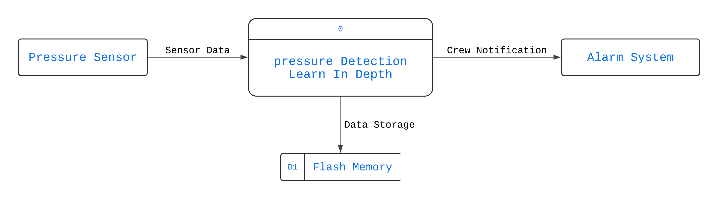

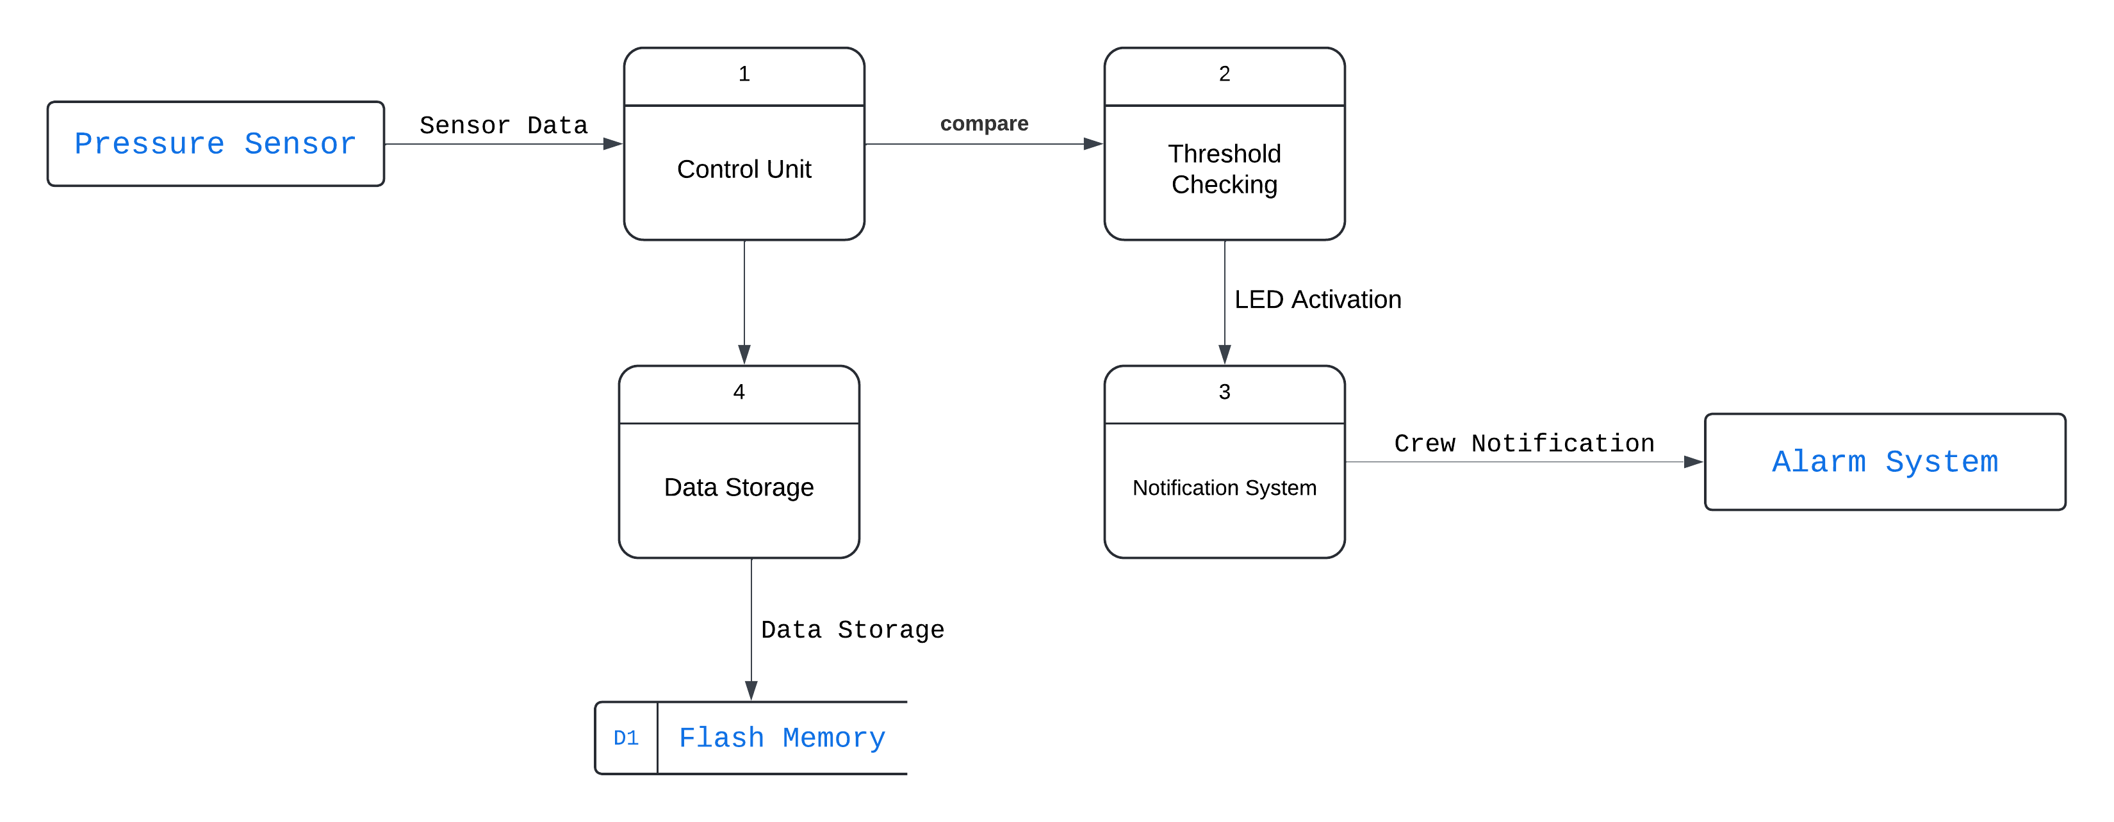**Level-0 DFD**

### ****4. Interface Design****

#### ****4.1 Hardware Interfaces****

* **Pressure Sensor:** Connects via GPIO pins
* **Alarm System:** Connects to Control Unit via GPIO pins

#### ****4.2 Software Interfaces****

* **Control Unit Software:** Handles data from sensors, processes information, and interfaces with the alarm and notification systems.
* **Notification System Software:** Receives alerts from the Control Unit and activates notifications.

### ****5. Error Handling****

#### ****5.1 Error Detection****

* **Sensor Failures:** Detect failures or inaccuracies in sensor readings.
* **Communication Errors:** Identify and handle issues with data transfer between components.

#### ****5.2 Error Response****

* **Redundant Systems:** Implement backup systems or alerts for critical failures.
* **Logs:** Maintain logs for error diagnosis and troubleshooting.

### ****6. Security****

#### ****6.1 Data Security****

* **Encryption:** Ensure sensitive data (if any) is encrypted.
* **Access Control:** Implement controls to restrict access to system data and configurations.

#### ****6.2 System Security****

* **Physical Security:** Protect hardware components from tampering.
* **Software Security:** Regular updates and patches to fix vulnerabilities.

### ****7. Performance****

#### ****7.1 Response Time****

* **Description:** The system must detect pressure changes and activate the alarm within 2 seconds.

#### ****7.2 Reliability****

* **Description:** The system must operate continuously with minimal downtime.

### ****8. Maintenance****

#### ****8.1 Regular Maintenance****

* **Description:** Periodic checks and updates to ensure system functionality.
* **Components:** Sensors, control units, and alarm systems.

#### ****8.2 Troubleshooting****

* **Description:** Procedures for diagnosing and fixing issues with the system.

### Sequence Diagram

### 

### Activity Diagram

### 

**System Design**

(Modules with its own state machines)

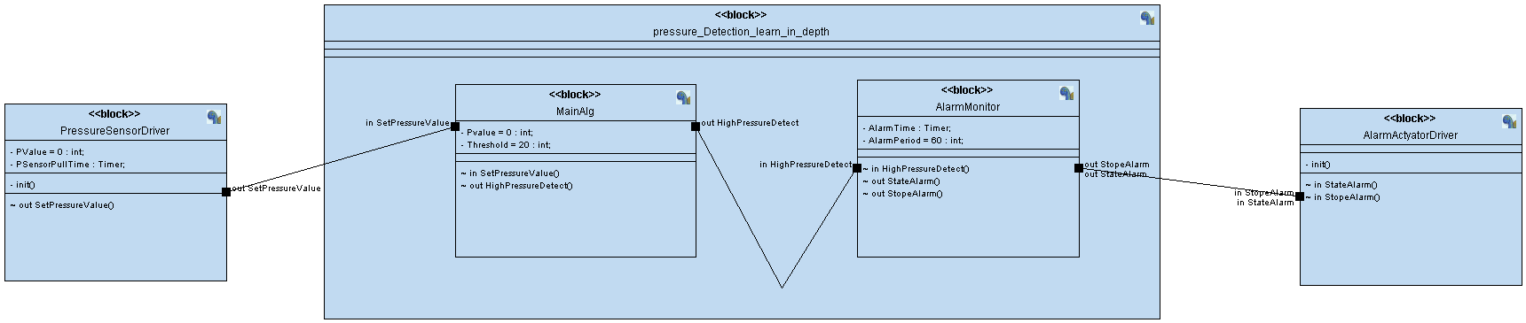

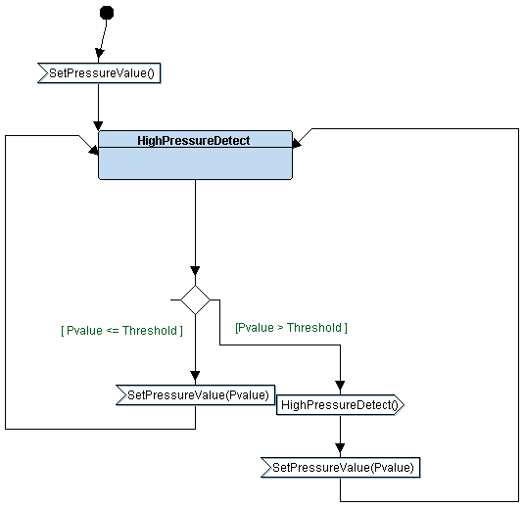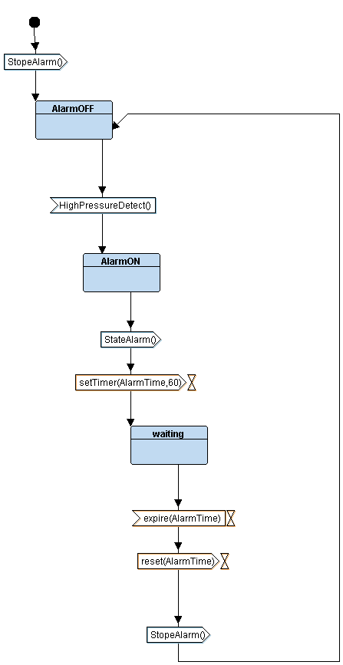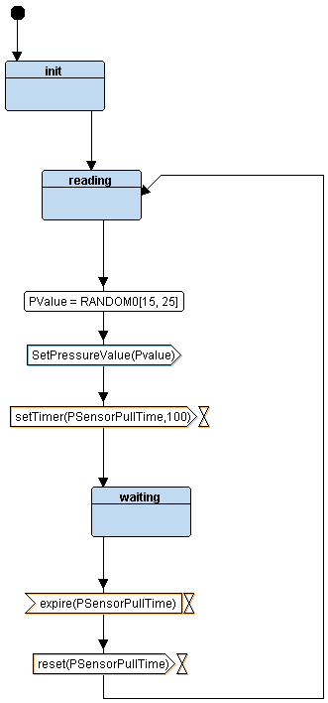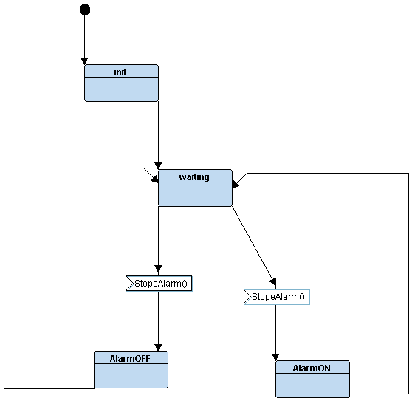

**MainAlg**

**AlarmMonitor**

**PressureSensorDriver**

**AlarmActyatorDriver**